## 9.1 Artefact

Below are screen shots of the artefact showing it, allowing the user to select a camera use front facing to rear facing, ask permissions to access the camera and then access the camera.

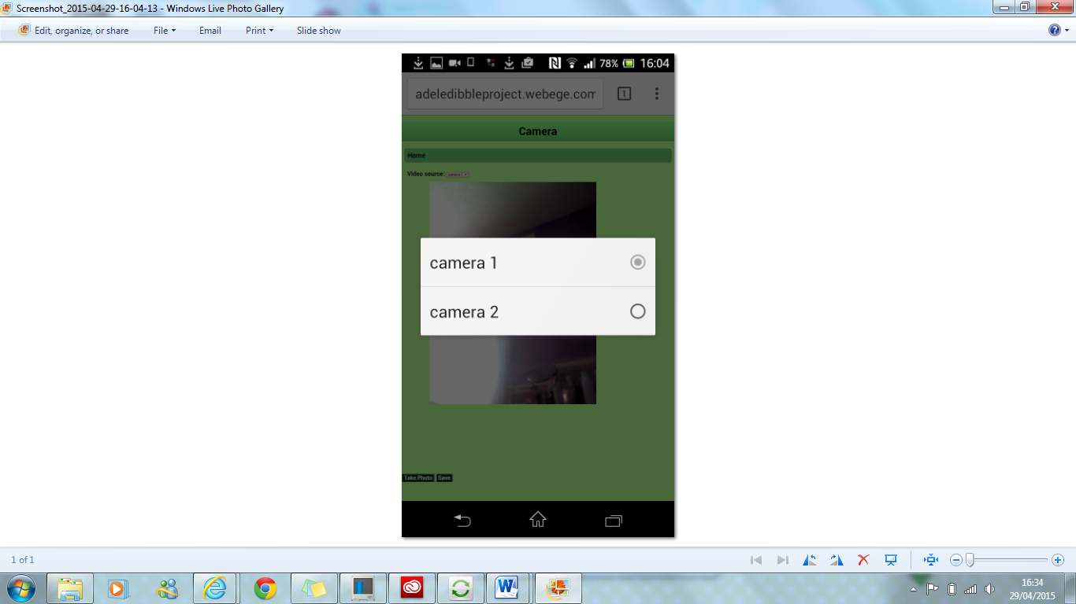which camera do you want to use front facing or rear facing.

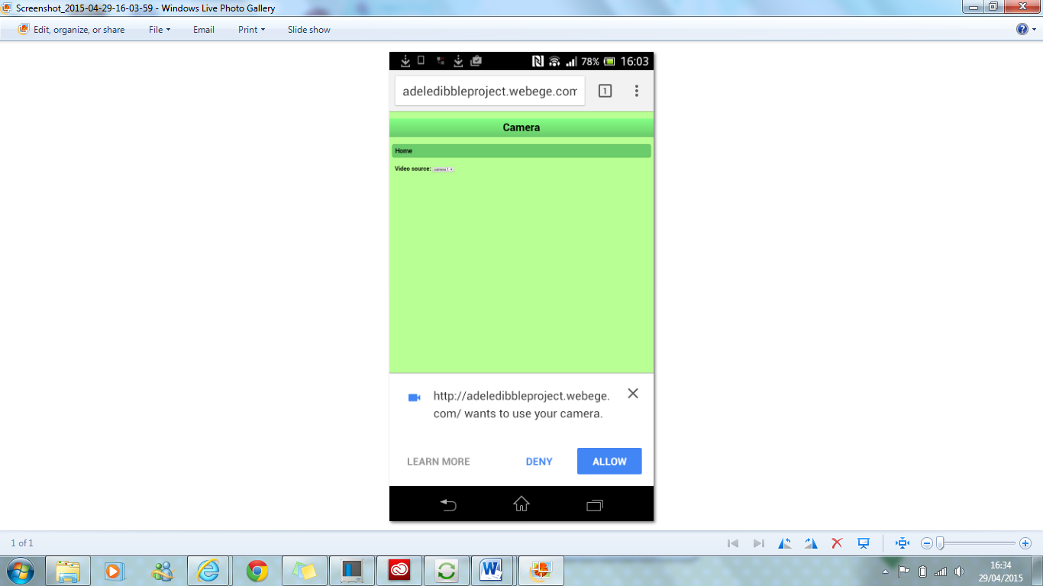this is asking the premissions after you have selected the camera to use, before loading up the camera.

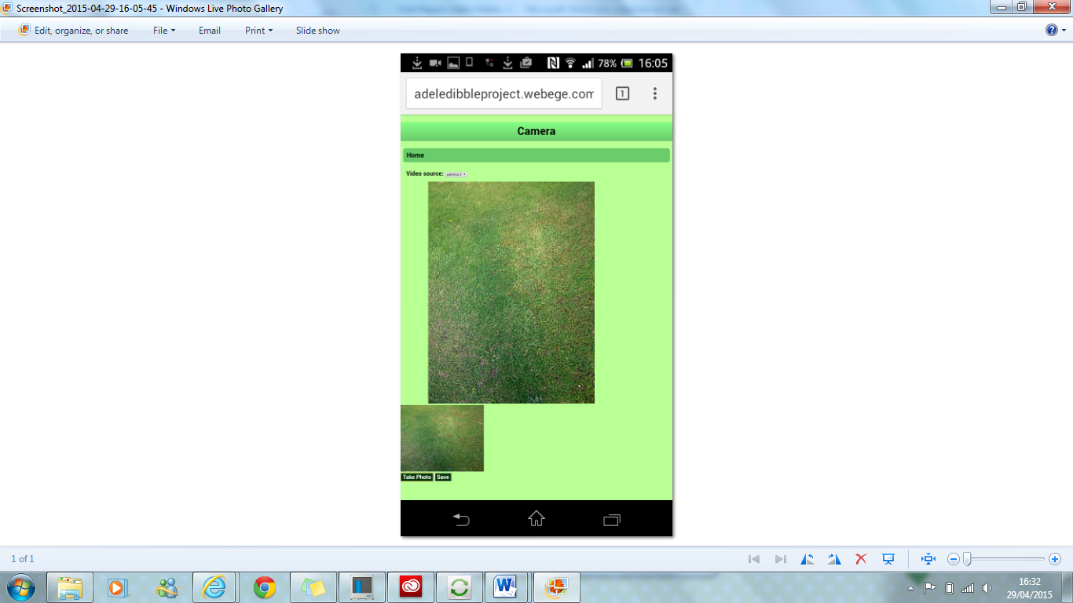taken a picture option to take another or to save this one and displays the picture it has just taken in a ‘preview’